**Graded-Assignment-On-Serverless-Architecture**

**Git hub repo: https://github.com/Ram495-ctrl/Serverless-Architecture_HV.git**

Assignment 1: Automated Instance Management Using AWS Lambda and Boto3

1. Creating EC2 Instances for AutoStart and AutoStop.

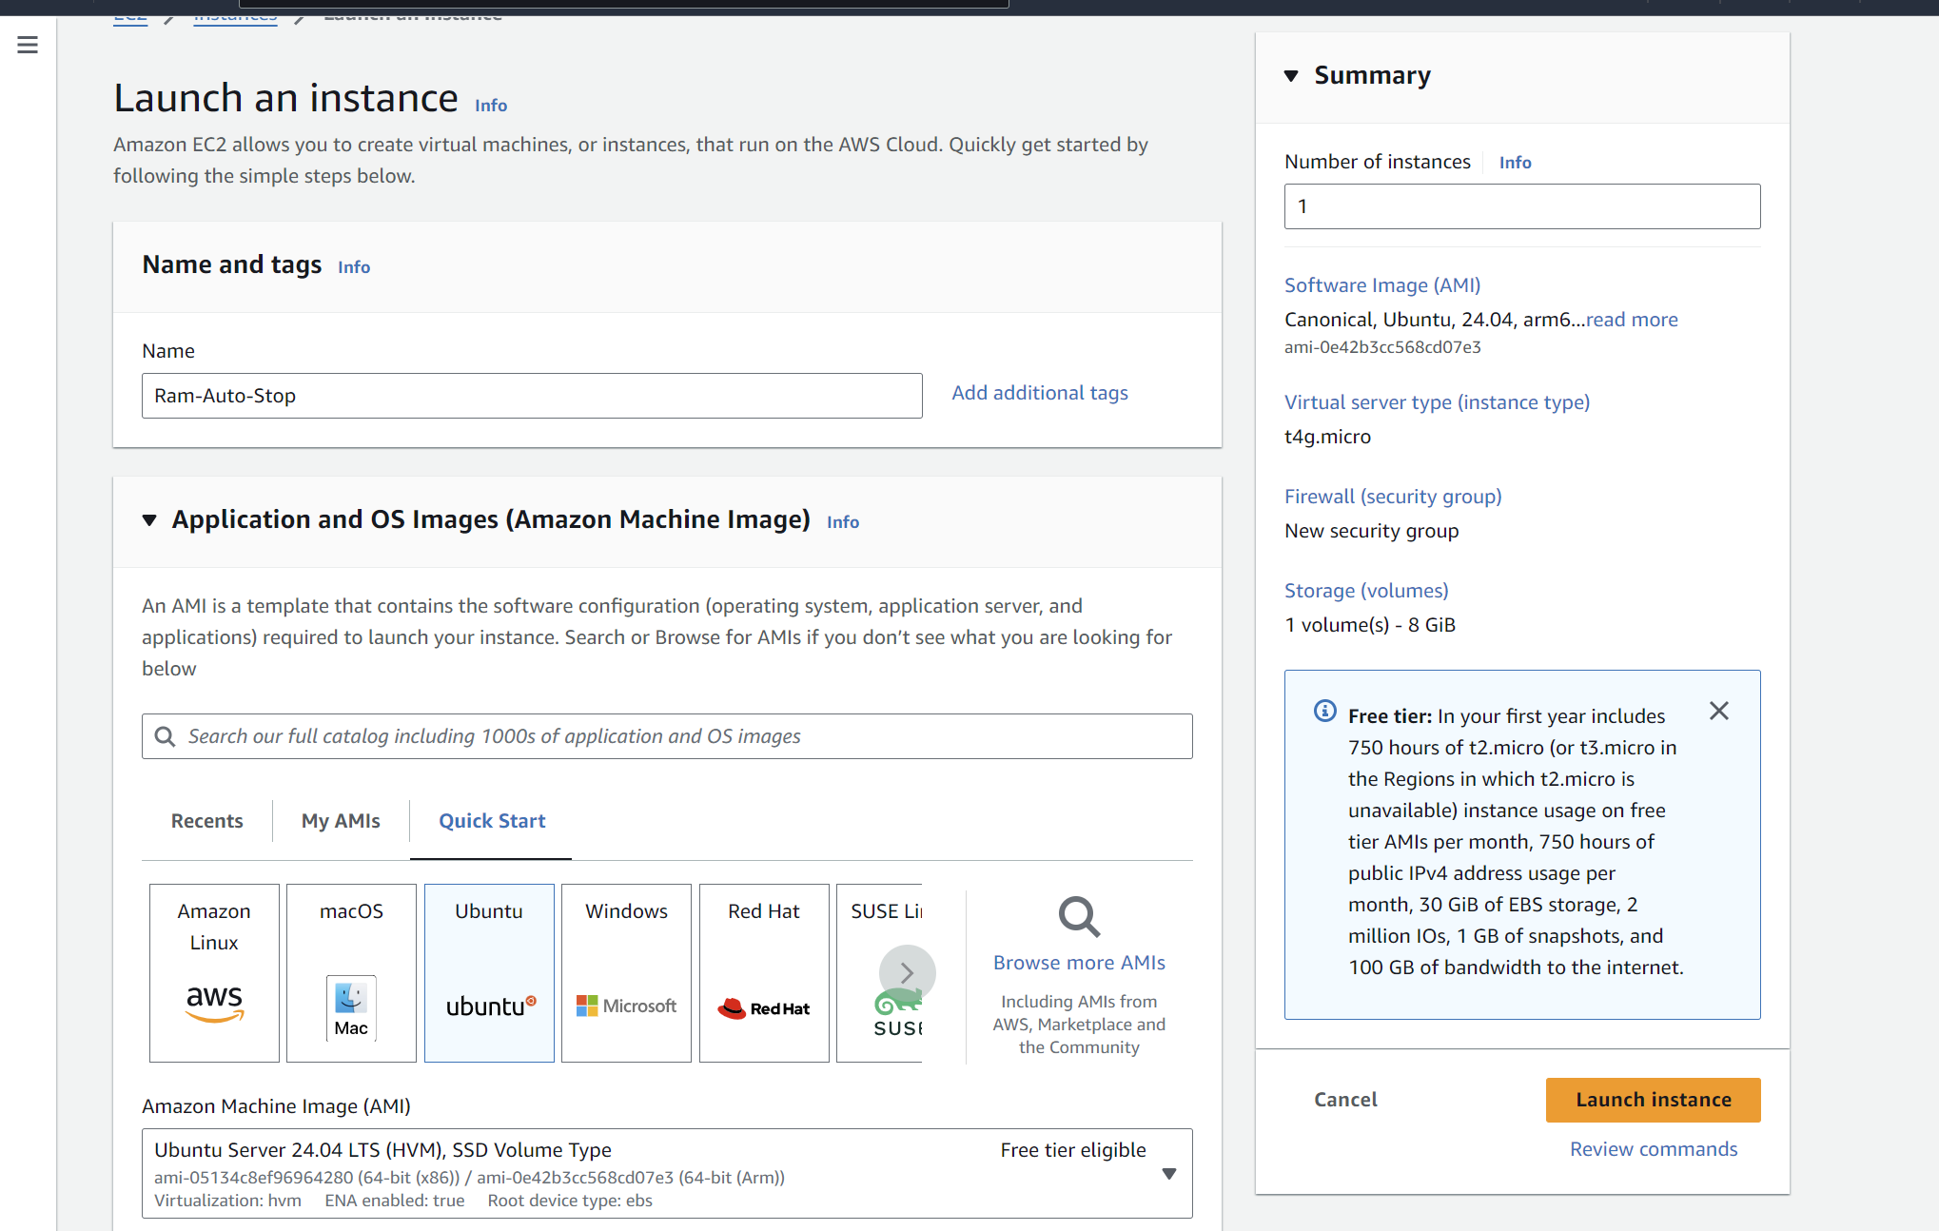

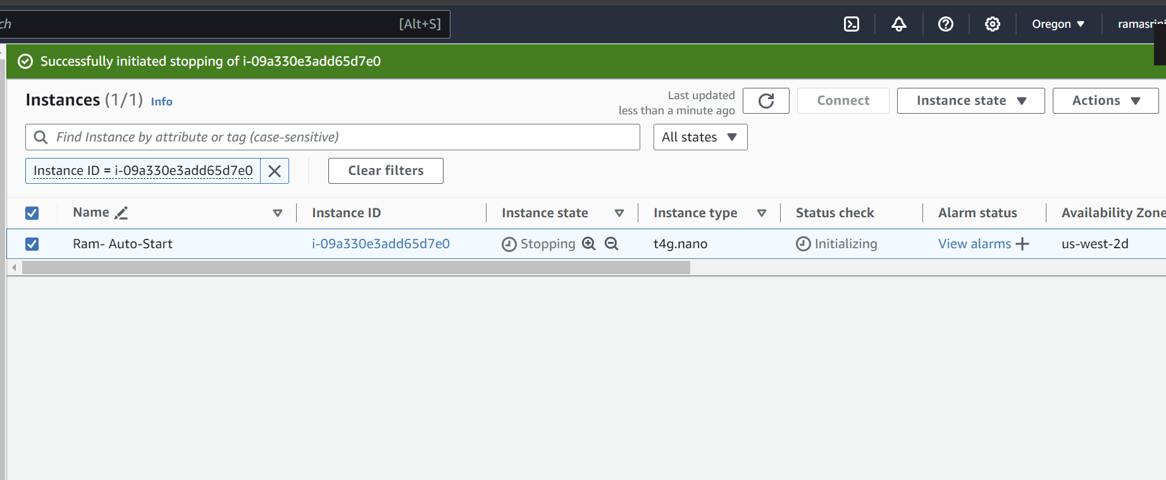

Ram Auto-start Create Tag:

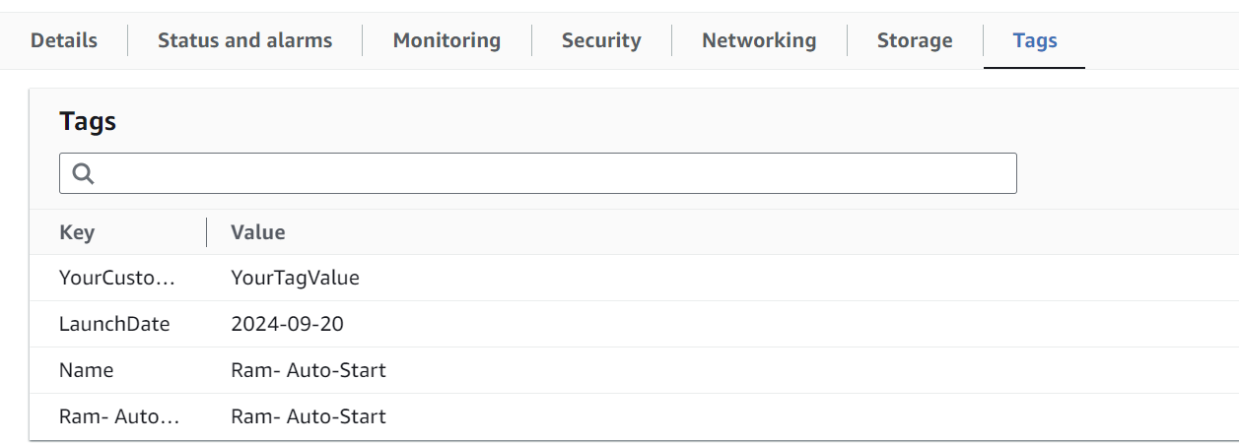

Similarly create EC2 for Auto stop (Ram-Auto-Stop) and make sure it is in stopped

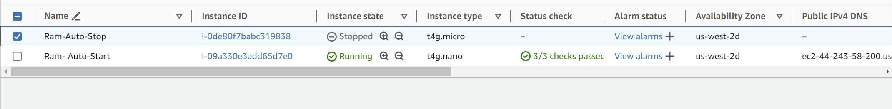

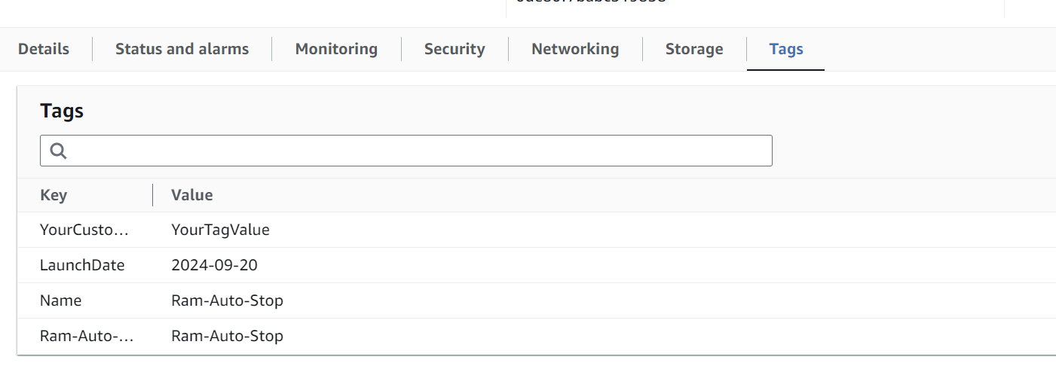

1. Created the IAM role for lamda function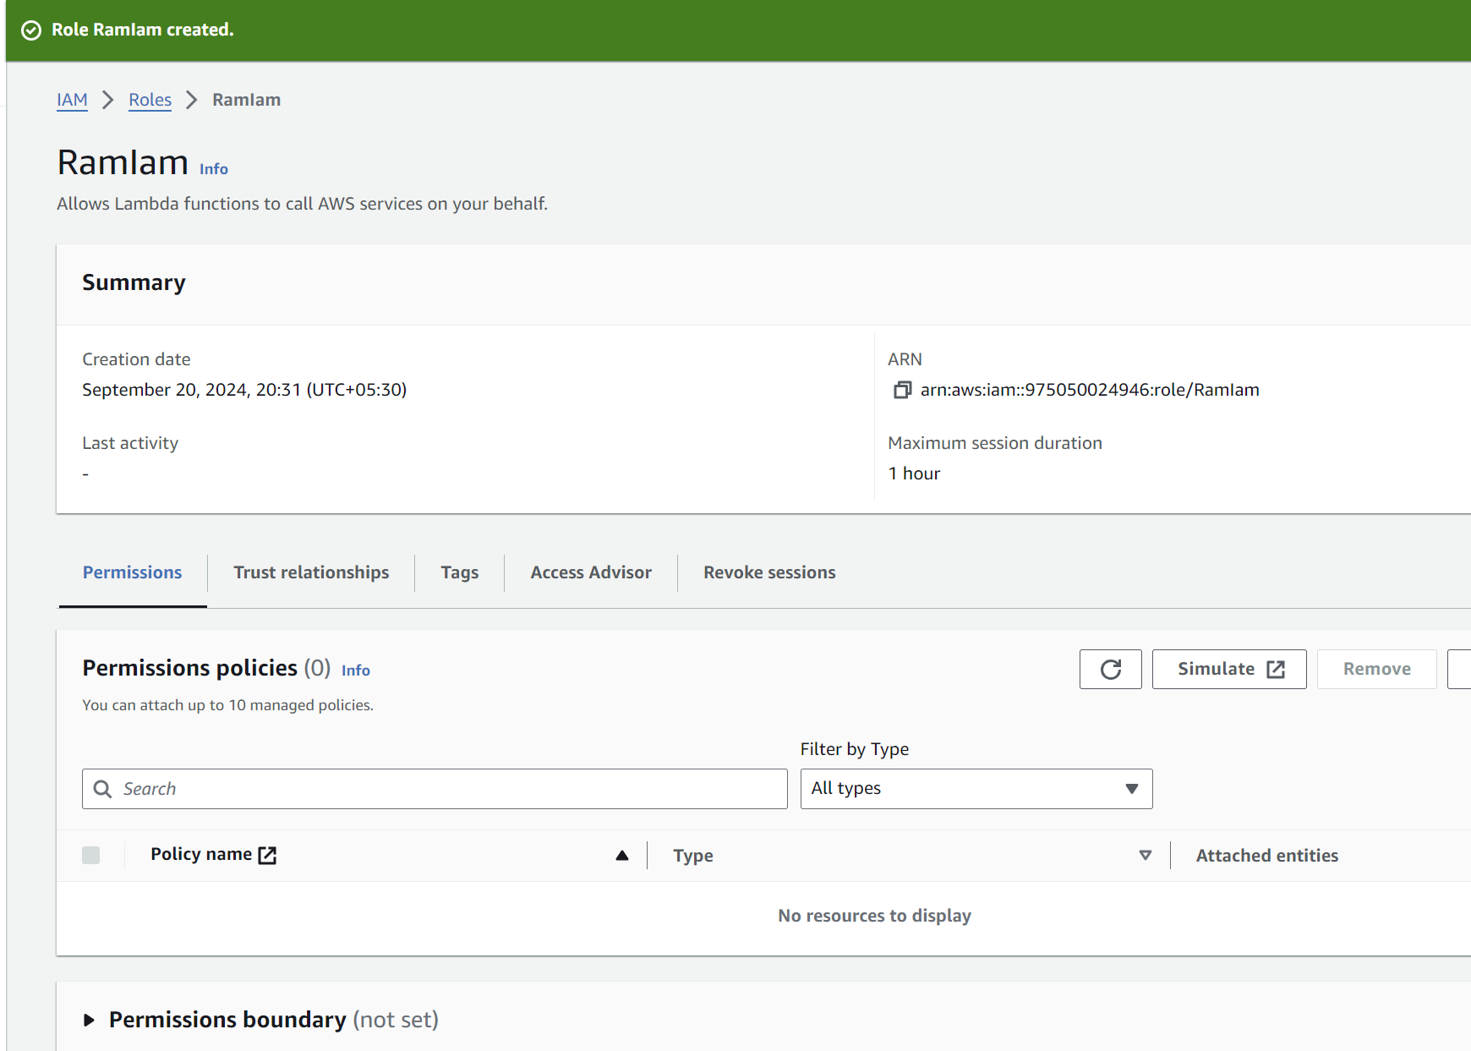

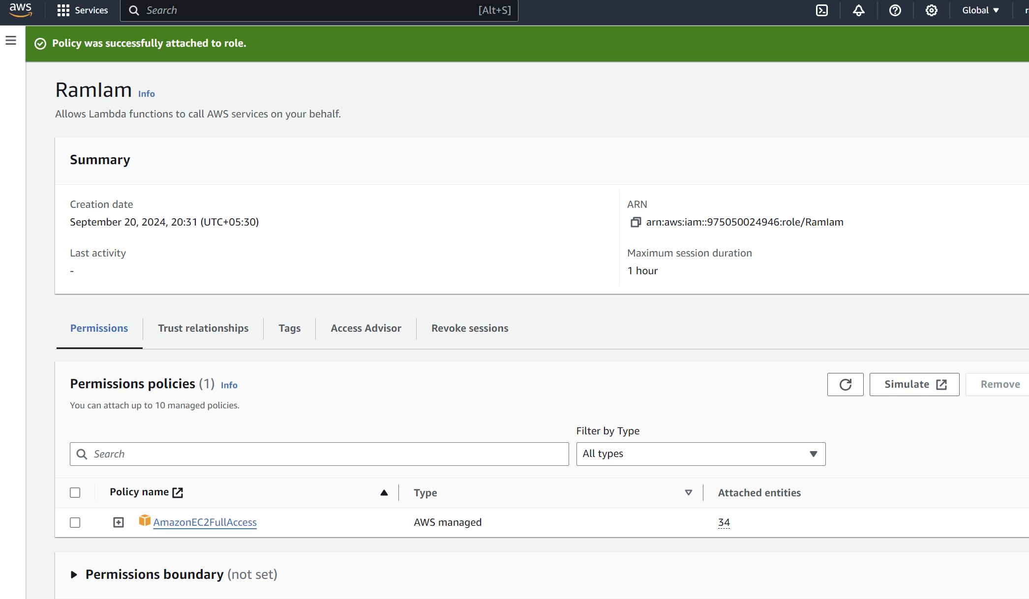

1. Added the python code in lamda function.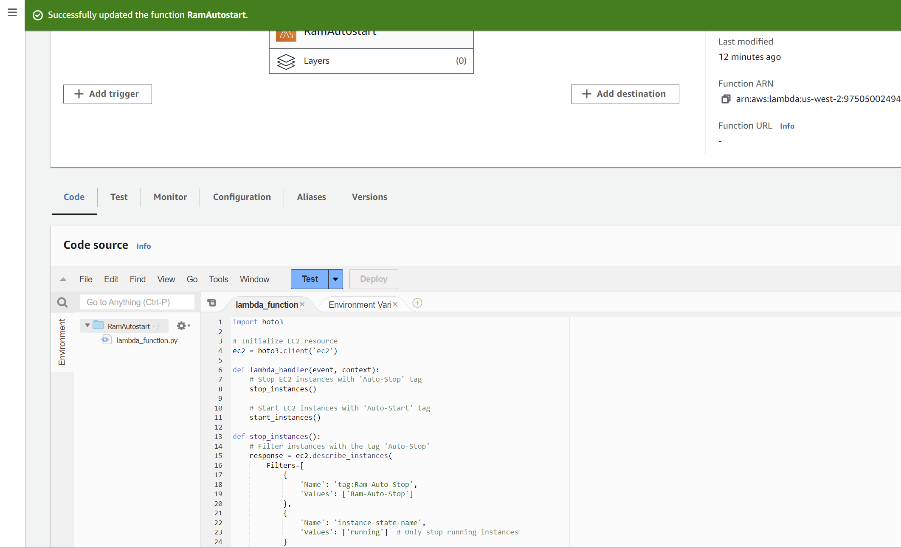

**Python code:**

import boto3

# Initialize EC2 resource

ec2 = boto3.client('ec2')

def lambda_handler(event, context):

# Stop EC2 instances with 'Auto-Stop' tag

stop_instances()

# Start EC2 instances with 'Auto-Start' tag

start_instances()

def stop_instances():

# Filter instances with the tag 'Auto-Stop'

response = ec2.describe_instances(

Filters=[

{

'Name': 'tag:Ram-Auto-Stop',

'Values': ['Ram-Auto-Stop']

},

{

'Name': 'instance-state-name',

'Values': ['running'] # Only stop running instances

}

]

)

instances_to_stop = []

for reservation in response['Reservations']:

for instance in reservation['Instances']:

instances_to_stop.append(instance['InstanceId'])

# Stop instances if any are found

if instances_to_stop:

print(f"Stopping instances: {instances_to_stop}")

ec2.stop_instances(InstanceIds=instances_to_stop)

else:

print("No instances found with the 'Auto-Stop' tag that are running.")

def start_instances():

# Filter instances with the tag 'Auto-Start'

response = ec2.describe_instances(

Filters=[

{

'Name': 'tag:Ram- Auto-Start',

'Values': ['Ram- Auto-Start']

},

{

'Name': 'instance-state-name',

'Values': ['stopped'] # Only start stopped instances

}

]

)

instances_to_start = []

for reservation in response['Reservations']:

for instance in reservation['Instances']:

instances_to_start.append(instance['InstanceId'])

# Start instances if any are found

if instances_to_start:

print(f"Starting instances: {instances_to_start}")

ec2.start_instances(InstanceIds=instances_to_start)

else:

print("No instances found with the 'Auto-Start' tag that are stopped.")

1. Created Lamda Fuction

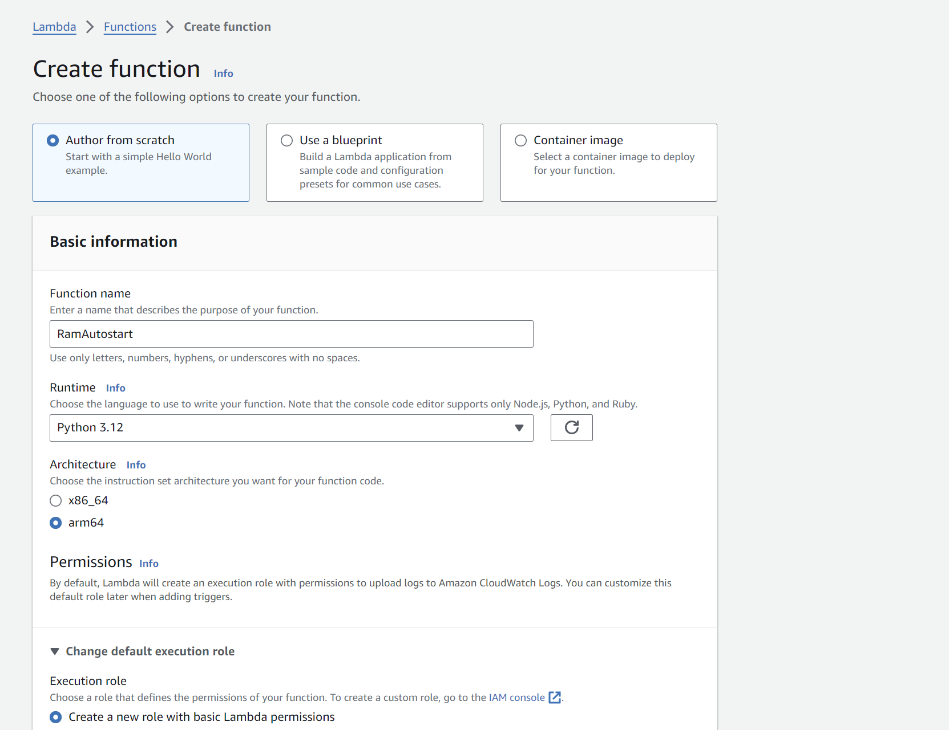

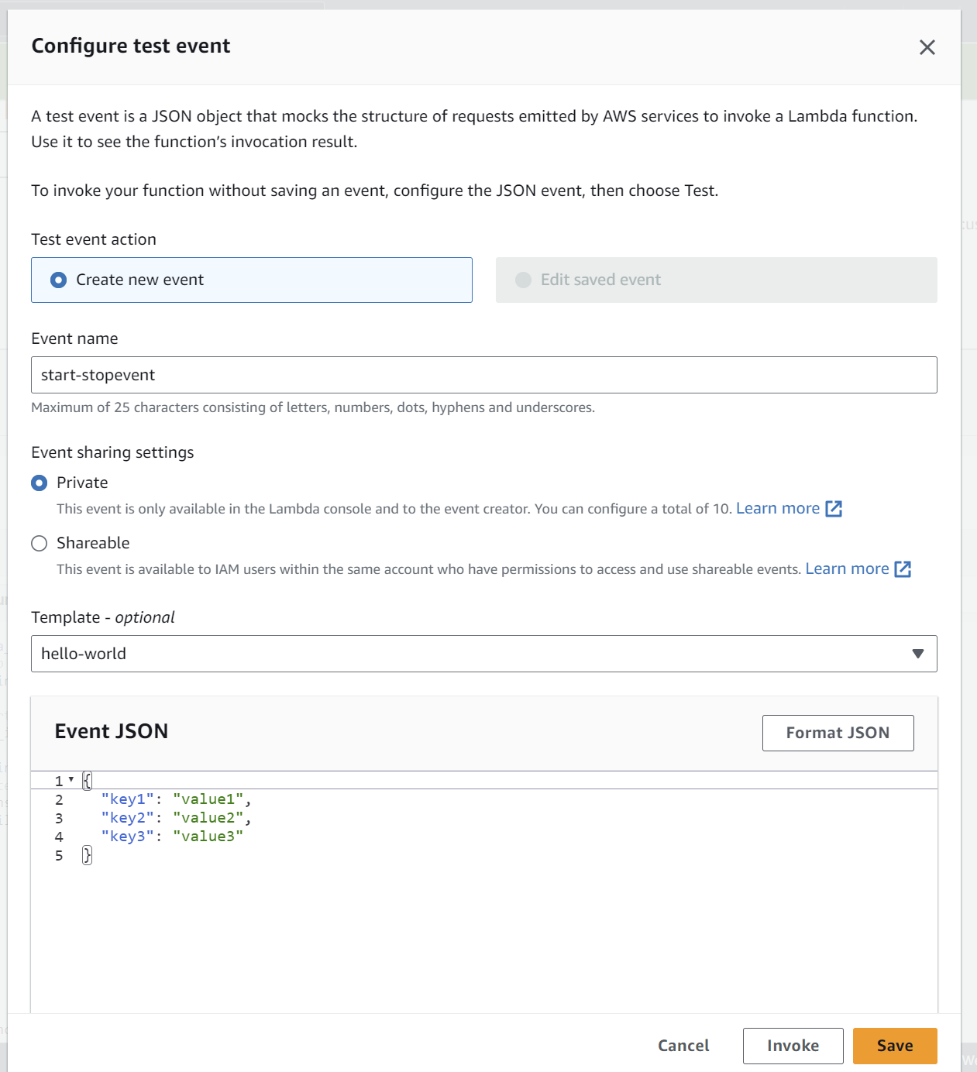

1. Deployed and tested the code. code executed sucesfully.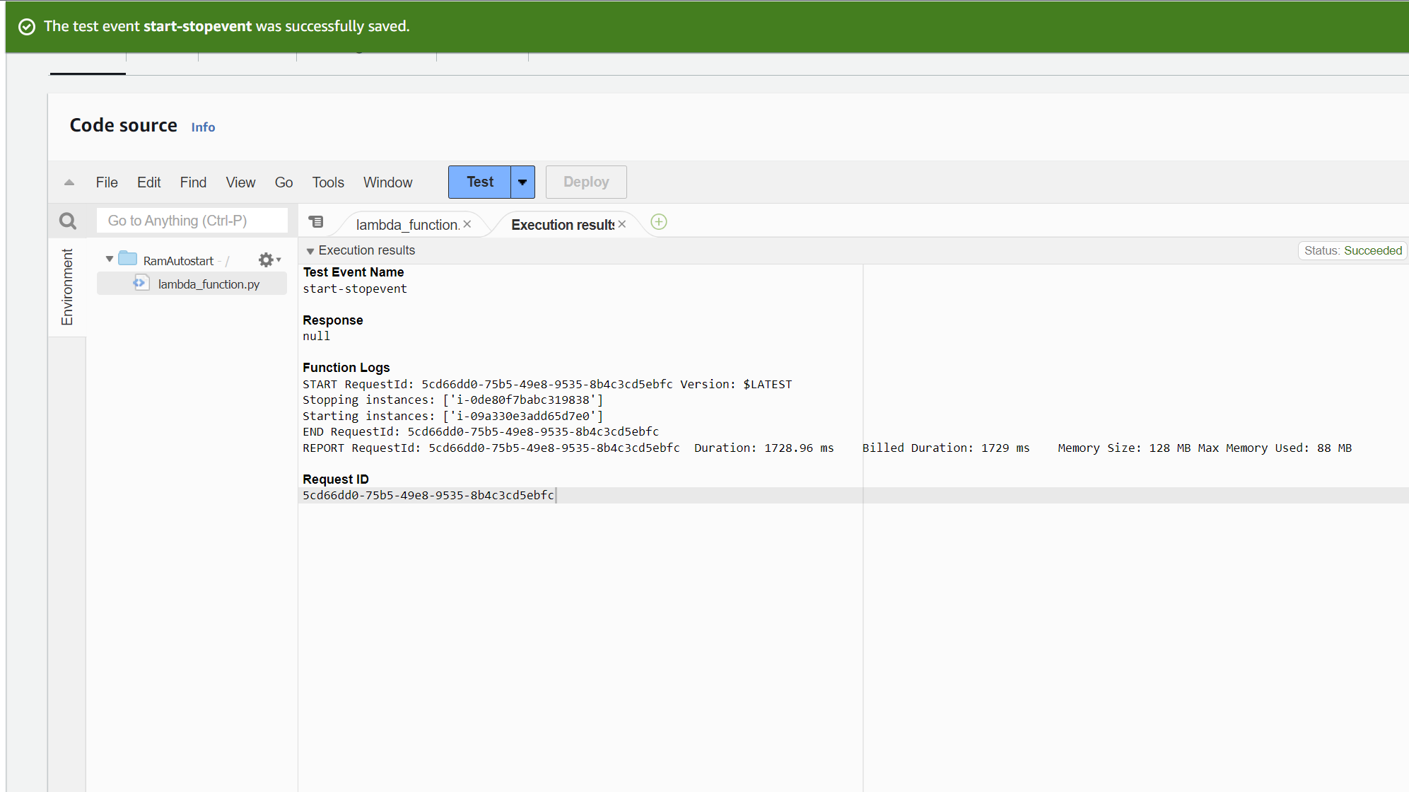

**Assignment 2**: Automated S3 Bucket Cleanup Using AWS Lambda and Boto3

1. S3 bucket Setup

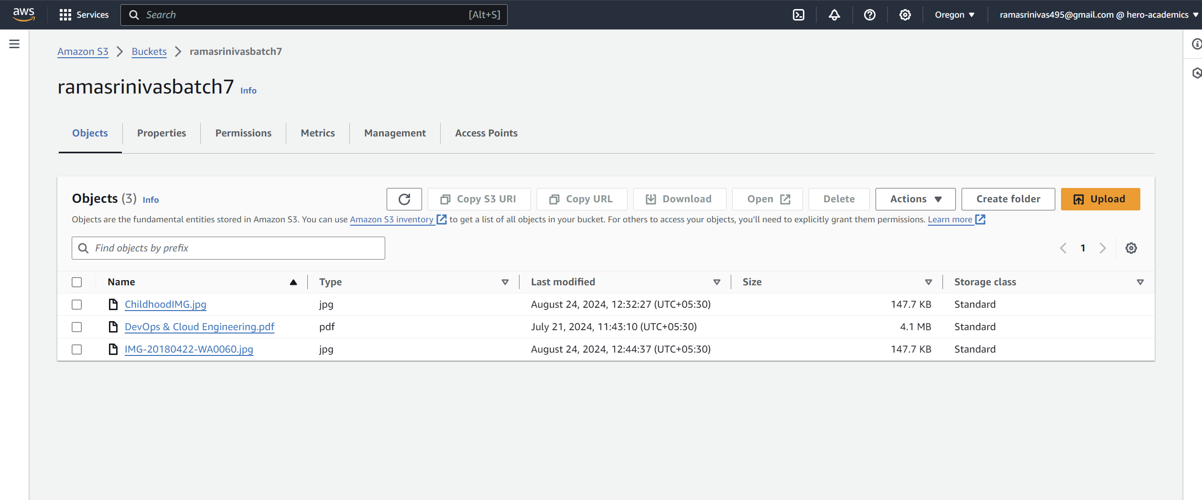

1. created the IAM role for lamda function

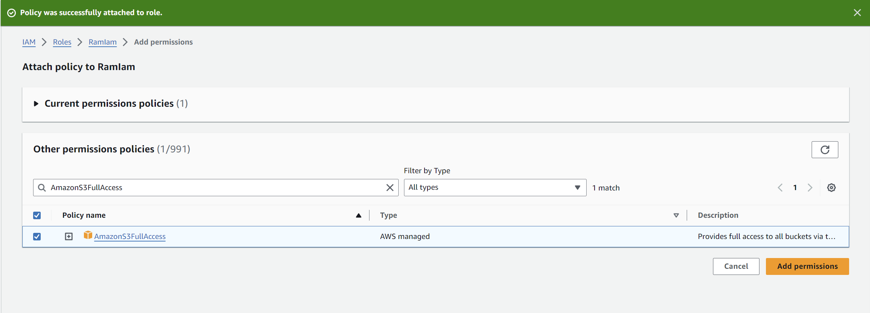

1. Using existing Lamda function, Modified the Python code

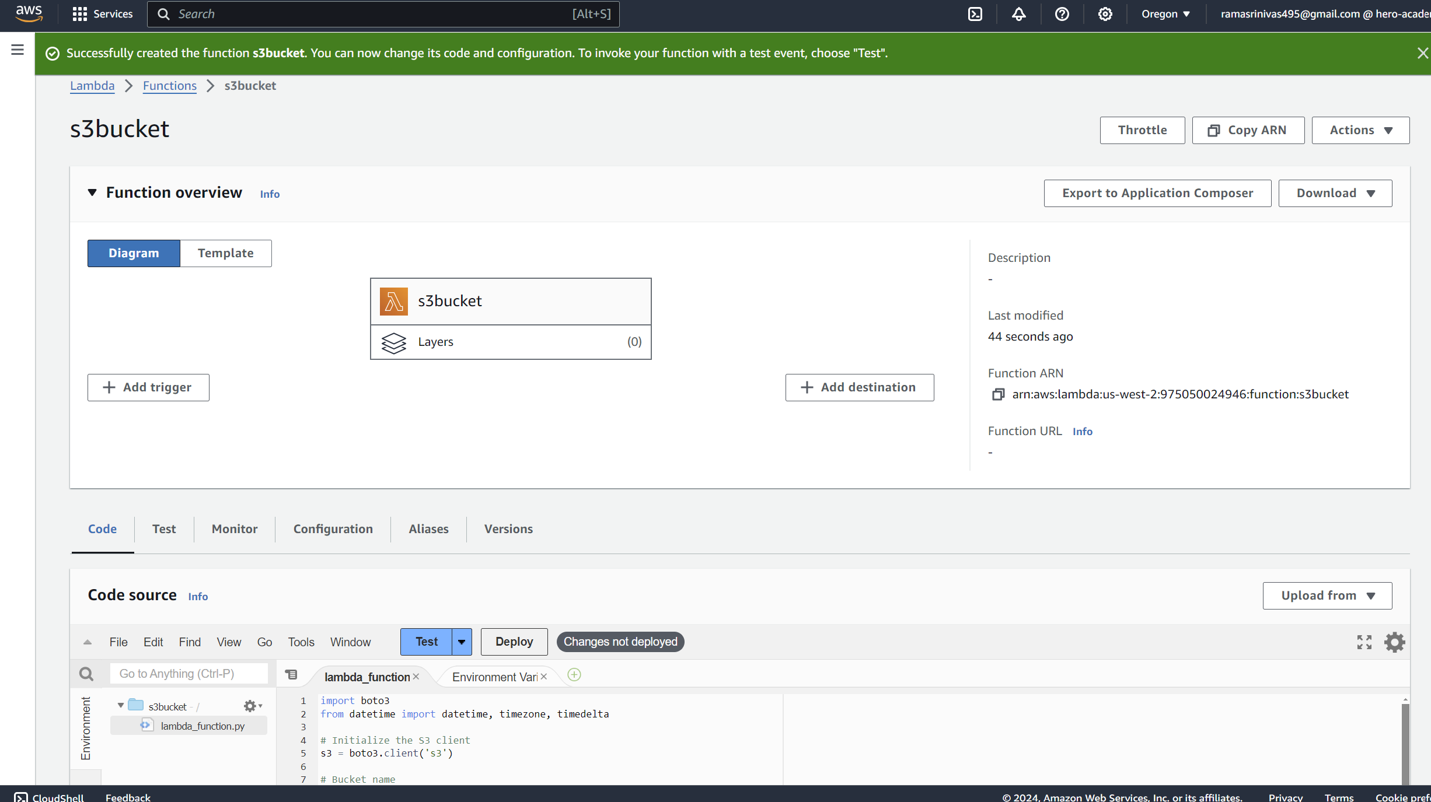

**Python code:**

import boto3

from datetime import datetime, timezone, timedelta

# Initialize the S3 client

s3 = boto3.client('s3')

# Bucket name

BUCKET_NAME = 'ramasrinivasbatch7'

# Time delta for 30 days

DAYS_OLD = 30

now = datetime.now(timezone.utc)

cutoff_date = now - timedelta(days=DAYS_OLD)

def delete_old_objects():

# List all objects in the bucket

response = s3.list_objects_v2(Bucket=BUCKET_NAME)

if 'Contents' not in response:

print("No objects found in the bucket.")

return

deleted_objects = []

for obj in response['Contents']:

# Get the object's LastModified time

last_modified = obj['LastModified']

# If the object is older than the cutoff date

if last_modified < cutoff_date:

print(f"Deleting object: {obj['Key']}")

s3.delete_object(Bucket=BUCKET_NAME, Key=obj['Key'])

deleted_objects.append(obj['Key'])

# Log the names of deleted objects

if deleted_objects:

print(f"Deleted objects: {deleted_objects}")

else:

print("No objects older than 30 days found.")

def lambda_handler(event, context):

delete_old_objects()

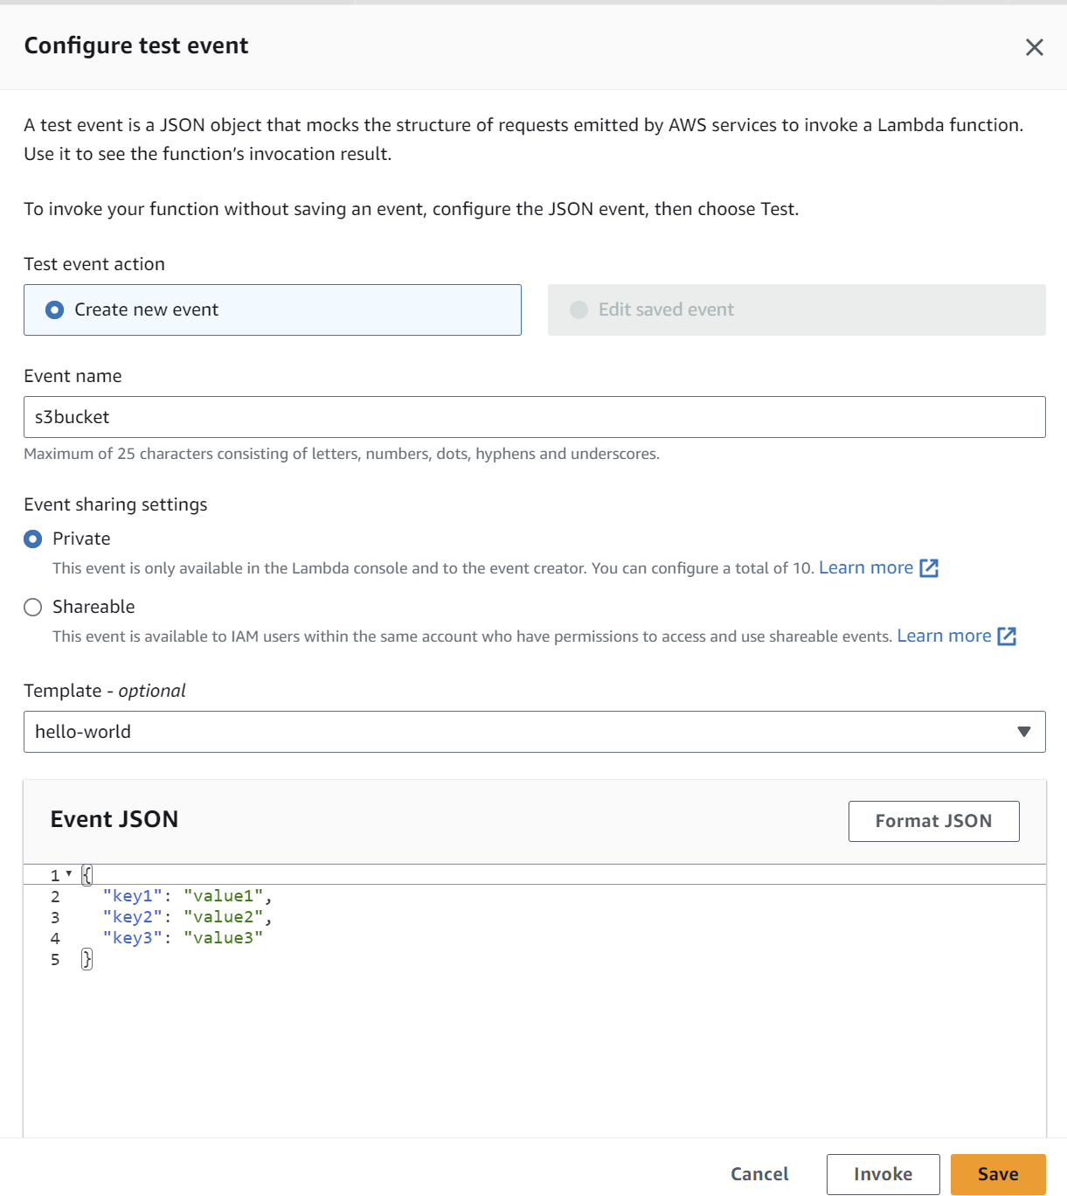

1. Deployed and tested the code(not able to add files older 30 days so modified the code with 30 sec).



Code executed deleted old file

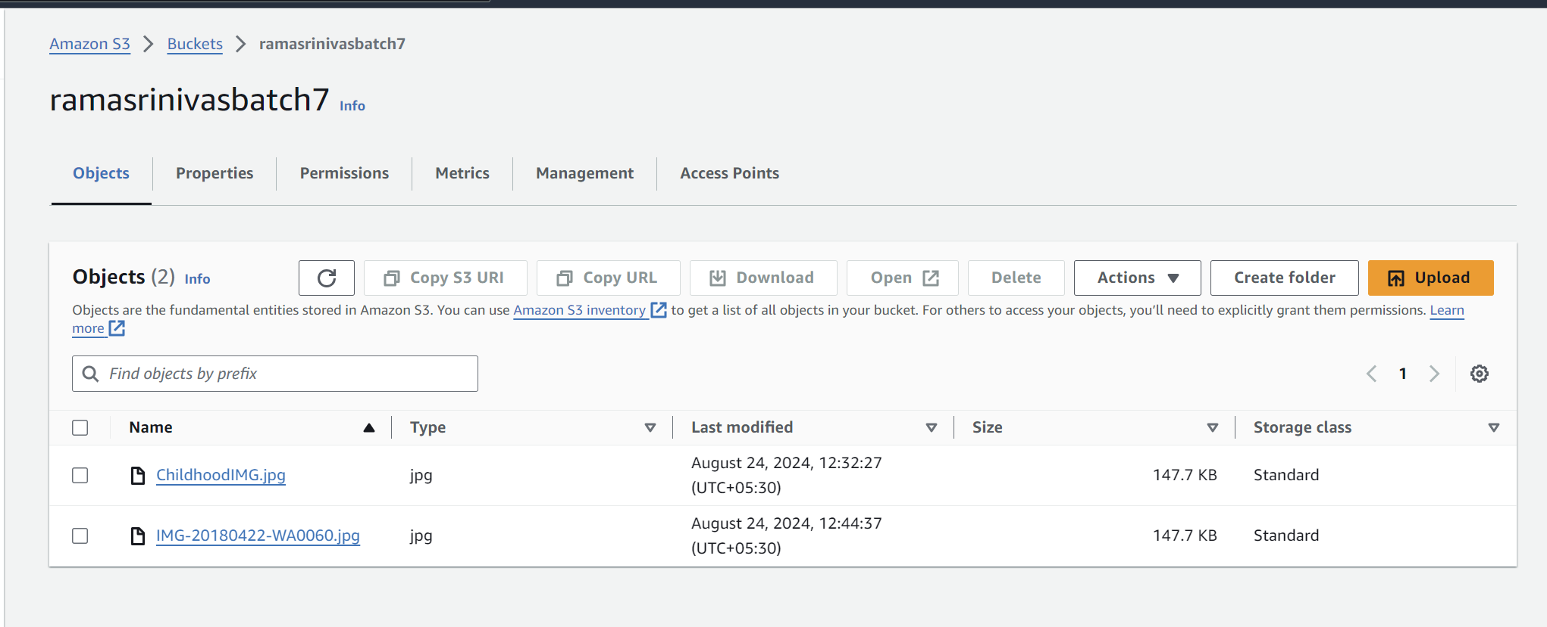

Q3: **Assignment 3**: Monitor Unencrypted S3 Buckets Using AWS Lambda and Boto3

1. created the IAM role for lamda function

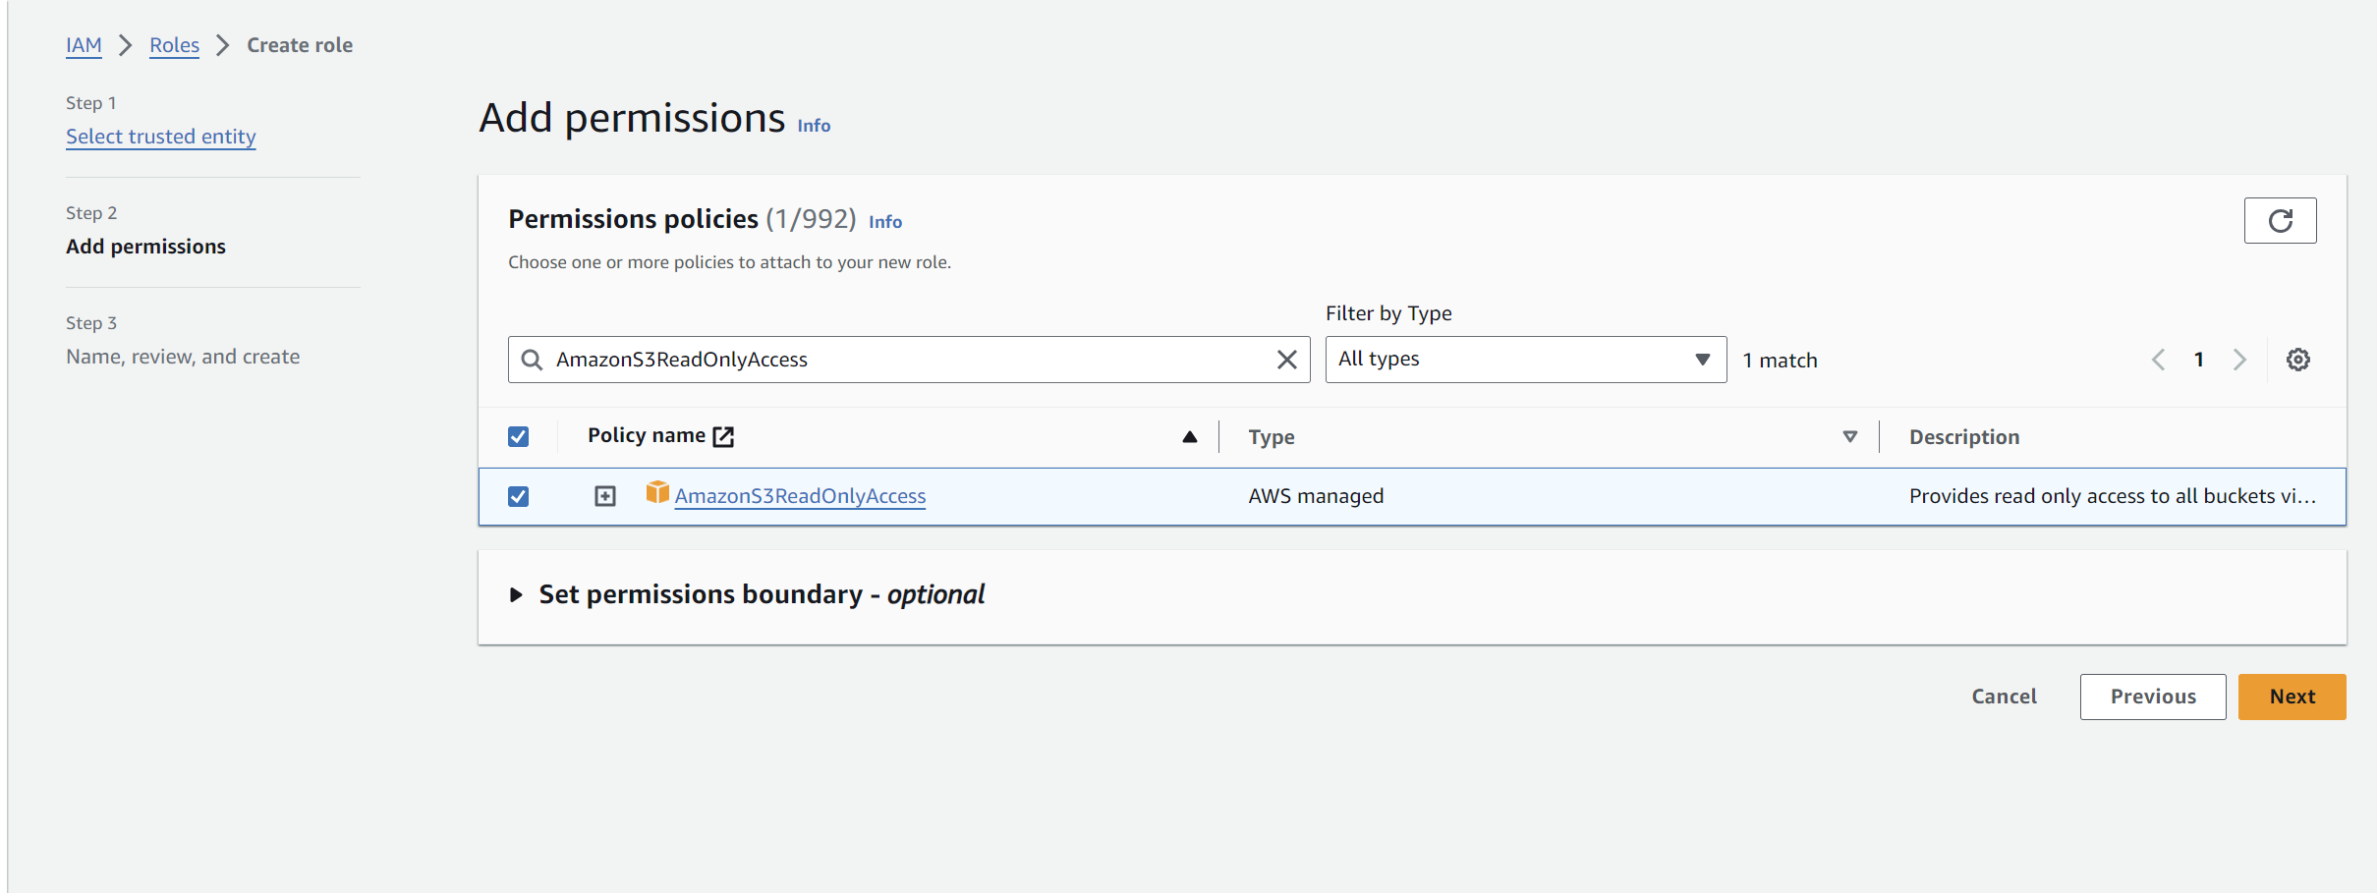

1. Using existing Lamda function, Modified the Python code

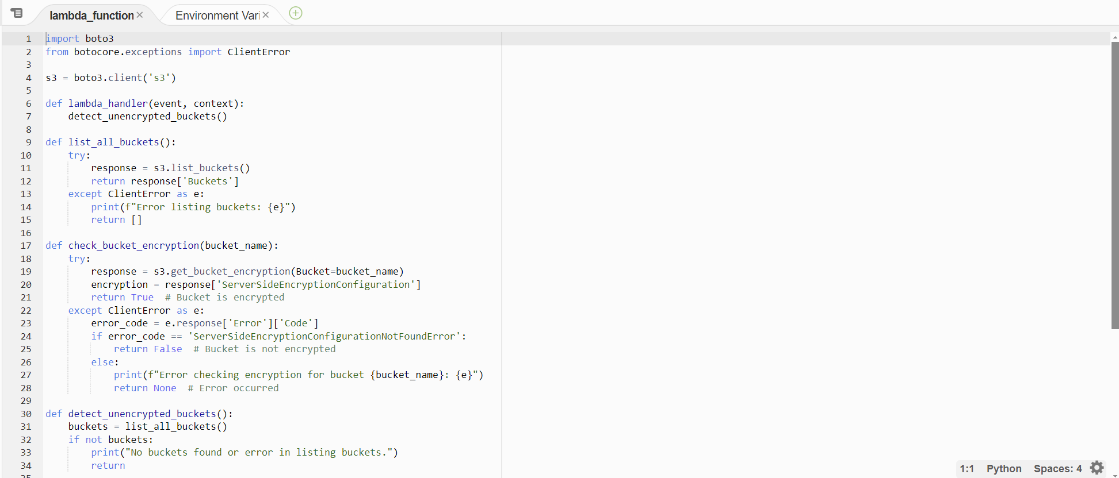

**Python code:**

import boto3

from botocore.exceptions import ClientError

s3 = boto3.client('s3')

def lambda_handler(event, context):

detect_unencrypted_buckets()

def list_all_buckets():

try:

response = s3.list_buckets()

return response['Buckets']

except ClientError as e:

print(f"Error listing buckets: {e}")

return []

def check_bucket_encryption(bucket_name):

try:

response = s3.get_bucket_encryption(Bucket=bucket_name)

encryption = response['ServerSideEncryptionConfiguration']

return True # Bucket is encrypted

except ClientError as e:

error_code = e.response['Error']['Code']

if error_code == 'ServerSideEncryptionConfigurationNotFoundError':

return False # Bucket is not encrypted

else:

print(f"Error checking encryption for bucket {bucket_name}: {e}")

return None # Error occurred

def detect_unencrypted_buckets():

buckets = list_all_buckets()

if not buckets:

print("No buckets found or error in listing buckets.")

return

unencrypted_buckets = []

for bucket in buckets:

bucket_name = bucket['Name']

is_encrypted = check_bucket_encryption(bucket_name)

if is_encrypted is False:

print(f"Bucket without encryption: {bucket_name}")

unencrypted_buckets.append(bucket_name)

elif is_encrypted is None:

print(f"Skipping bucket {bucket_name} due to an error.")

if unencrypted_buckets:

print(f"Unencrypted buckets: {unencrypted_buckets}")

else:

print("All buckets have server-side encryption enabled.")

1. Code executed properly

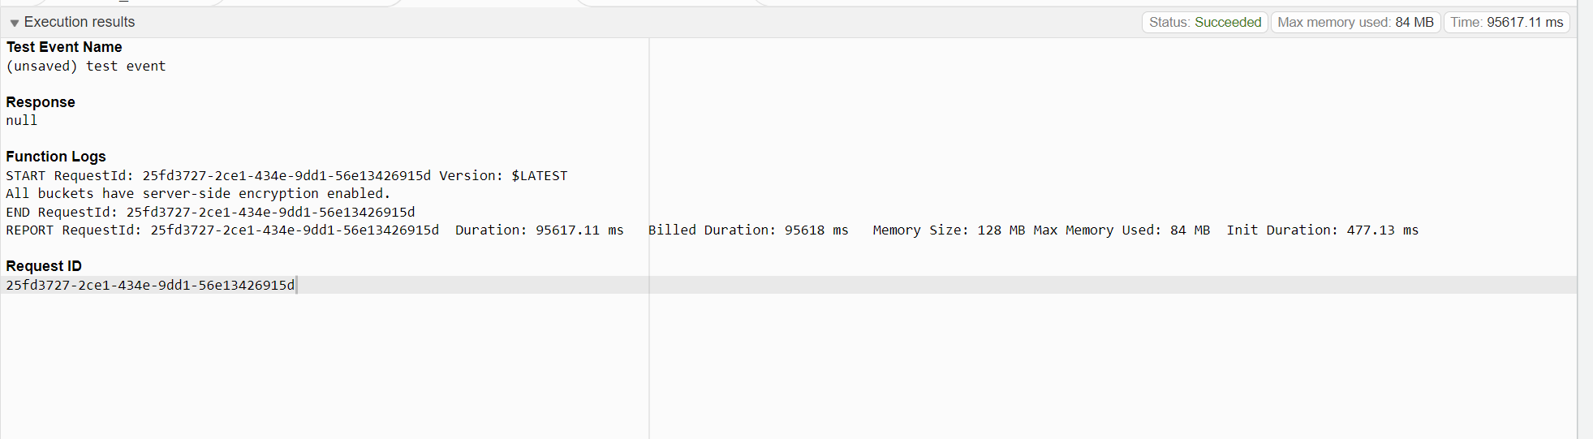

**Assignment 4**: Automatic EBS Snapshot and Cleanup Using AWS Lambda and Boto3

Created EC2 instance

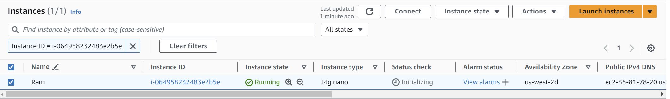

Created EBS volume

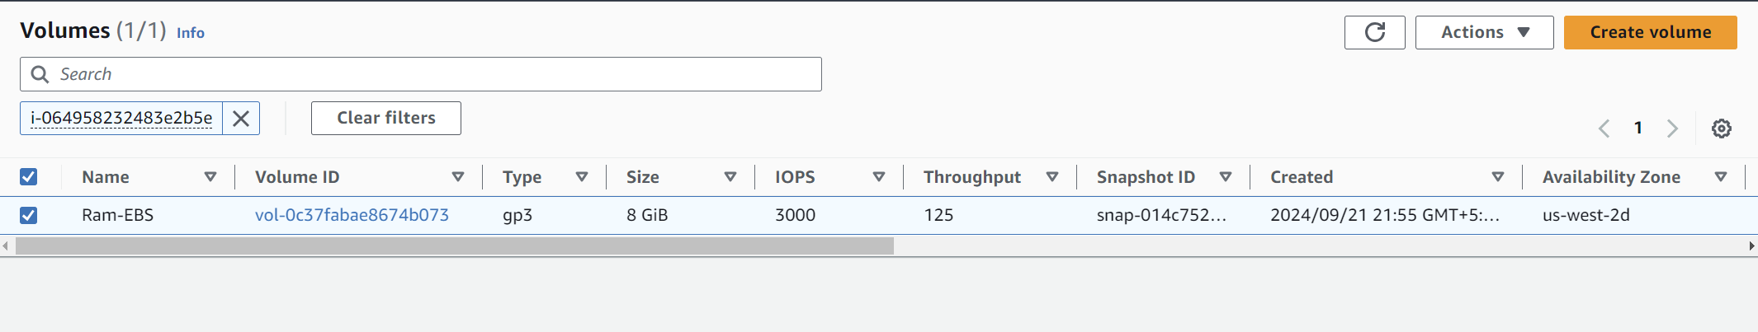

Added role AmazonEC2FullAccess to IAM



Using existing Lamda function, Modified the Python code

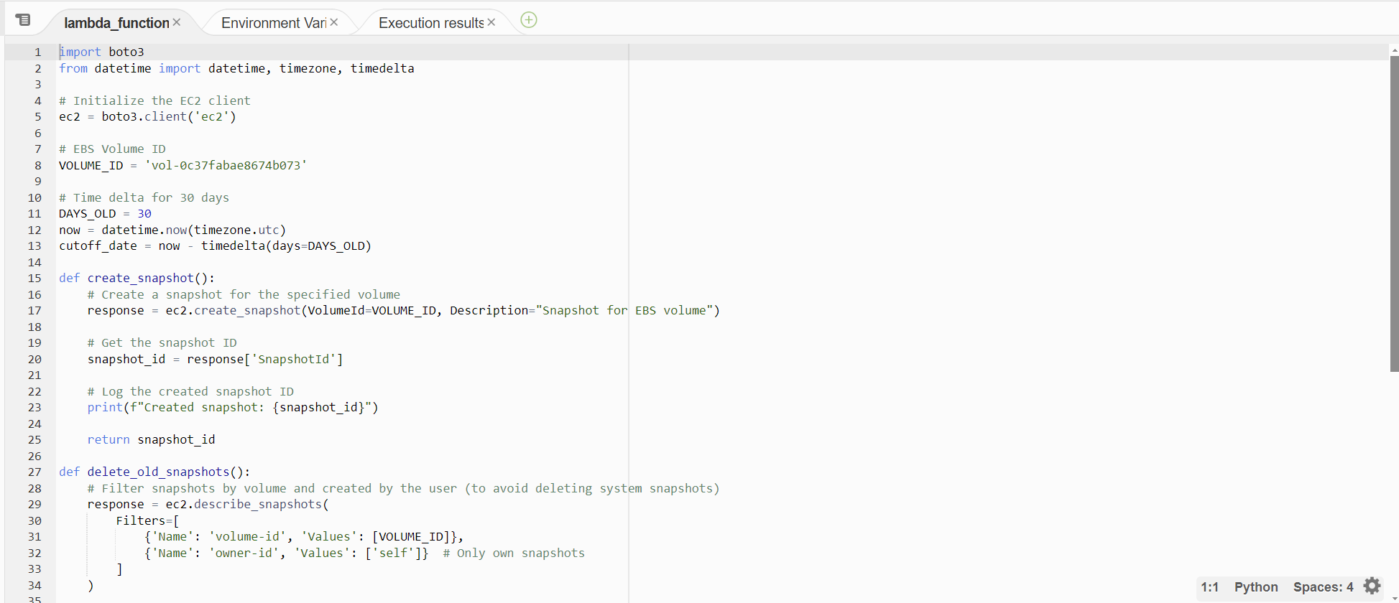

**Python code:**

import boto3

from datetime import datetime, timezone, timedelta

# Initialize the EC2 client

ec2 = boto3.client('ec2')

# EBS Volume ID

VOLUME_ID = 'vol-0c37fabae8674b073'

# Time delta for 30 days

DAYS_OLD = 30

now = datetime.now(timezone.utc)

cutoff_date = now - timedelta(days=DAYS_OLD)

def create_snapshot():

# Create a snapshot for the specified volume

response = ec2.create_snapshot(VolumeId=VOLUME_ID, Description="Snapshot for EBS volume")

# Get the snapshot ID

snapshot_id = response['SnapshotId']

# Log the created snapshot ID

print(f"Created snapshot: {snapshot_id}")

return snapshot_id

def delete_old_snapshots():

# Filter snapshots by volume and created by the user (to avoid deleting system snapshots)

response = ec2.describe_snapshots(

Filters=[

{'Name': 'volume-id', 'Values': [VOLUME_ID]},

{'Name': 'owner-id', 'Values': ['self']} # Only own snapshots

]

)

deleted_snapshots = []

for snapshot in response['Snapshots']:

snapshot_id = snapshot['SnapshotId']

start_time = snapshot['StartTime']

# If the snapshot is older than the cutoff date

if start_time < cutoff_date:

print(f"Deleting snapshot: {snapshot_id} (Created on {start_time})")

ec2.delete_snapshot(SnapshotId=snapshot_id)

deleted_snapshots.append(snapshot_id)

# Log the deleted snapshot IDs

if deleted_snapshots:

print(f"Deleted snapshots: {deleted_snapshots}")

else:

print("No snapshots older than 30 days found.")

def lambda_handler(event, context):

# Step 1: Create a new snapshot

created_snapshot_id = create_snapshot()

# Step 2: Delete old snapshots older than 30 days

delete_old_snapshots()

Code executed

